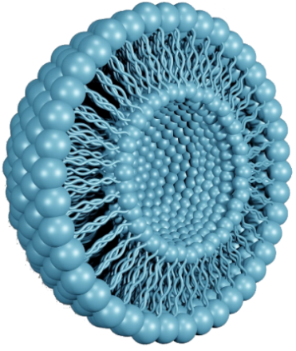**NANOPHOSPHOSOME**

Nanophosphosome® technology has emerged as a crucial advancement in drug delivery, research, and cosmetics. These small, spherical vesicles, composed of lipid bilayers, are designed to enhance the stability and bioavailability of encapsulated compounds. By protecting drugs or nutrients from degradation and improving their absorption, Nanophosphosome® technology provides an innovative solution for effective therapeutic applications.

**Properties of Nanophosphosome®**

* Composed of lipid bilayers that can encapsulate both hydrophilic and hydrophobic substances.
* Provides stability to active compounds, preventing premature degradation.
* Enables controlled release, enhancing pharmacokinetics and pharmacodynamics.
* Designed for targeted delivery, improving absorption through biological barriers.

**Benefits of Nanophosphosome® Technology**

* Enhances drug absorption and bioavailability.
* Reduces required dosage while maintaining therapeutic effectiveness.
* Minimizes side effects by ensuring controlled and targeted release.
* Improves stability, reducing degradation of sensitive compounds.
* Offers versatility for human and veterinary applications.

**Applications of Nanophosphosome®**

* **Pharmaceuticals**: Enhances drug delivery for improved clinical outcomes.
* **Cosmetics**: Provides better absorption and stability for skincare and beauty products.
* **Nutraceuticals**: Improves the bioavailability of dietary supplements.
* **Veterinary Medicine**: Enables targeted drug delivery for animals.
* **Research & Development**: Facilitates advancements in nanotechnology-driven therapeutics.



***Curcuma longa***



***Berberis vulgaris***



***Tagetes erecta***



**Introduction**

Neuna® particles are extremely small and have dimensions roughly between 1-100 nanometers (nm). Nanospheres are matrix systems in which the drug is physically and uniformly dispersed. Nano capsules are systems in which the drug is confined to a cavity surrounded by a unique polymer membrane.

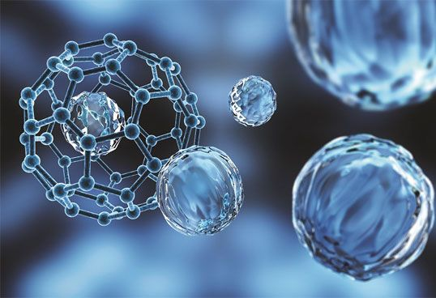

**Properties of Neuna® particle**

* High Mobility
* Higher Absorption
* Enormous Surface Area
* Chemical Stability

**Benefits of Neuna® particle**

* Enhances Reactivity
* Improves Strength and Durability
* Site-specific delivery of drugs
* Neuna® particles help to achieve maximum therapeutic response with minimum adverse effects

**Application of Neuna® particle**

1. **Research**

* Drug Screening
* Gene Delivery
* Diagnosis

1. **Clinical**

* Drug Delivery
* Detection
* Diagnosis Monitoring

1. **Agriculture**
2. **Veterinary and Aquaculture**

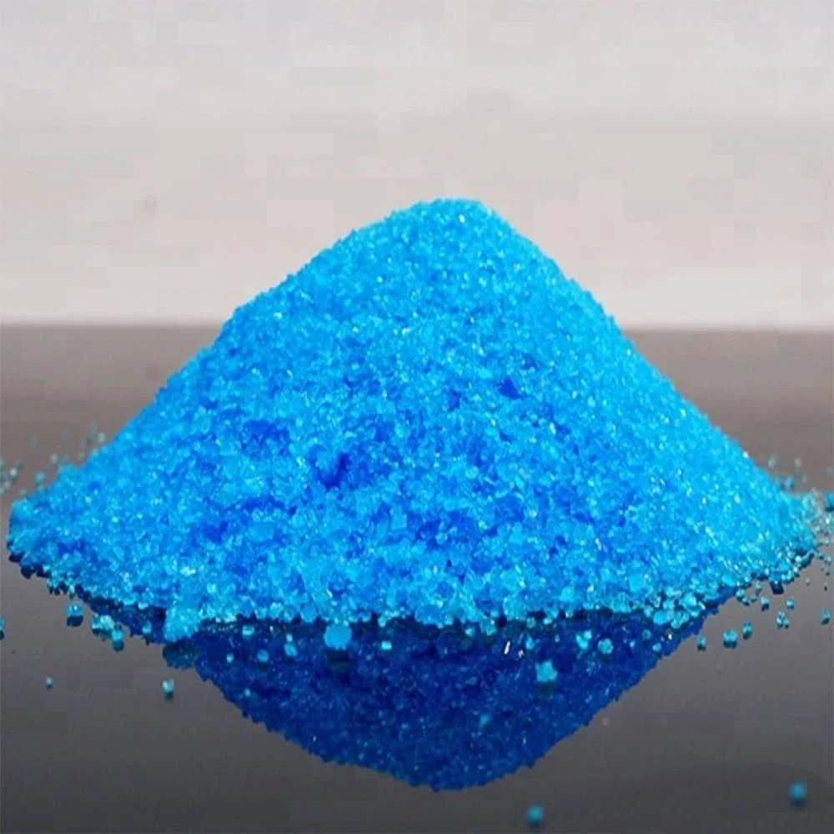

**Copper Neuna®**

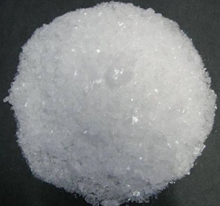

**Silver Neuna®**

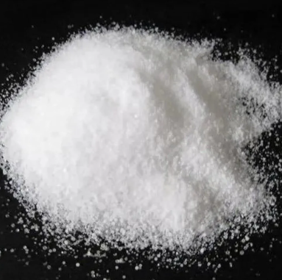

**Zinc Neuna®**

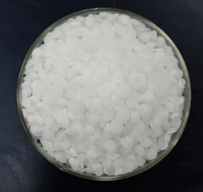

**Potassium Neuna®**

**NEUNA® MIN**

Neuna® Min is a range of highly effective and bioavailable carbon technology based nano minerals.

**Nano Size Molecules with Superior Absorption:** 20-100 nm particle size ensures Passive Diffusion

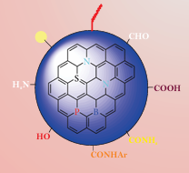**Technology used:**

1. **Carbon Quantum Dots (CQDs)**

Carbon Quantum Dots passivated Minerals (CQD Minerals) is a highly bioavailable form of supplemental minerals which can be used further for the production of high-quality mineral feeds and supplements.

1. 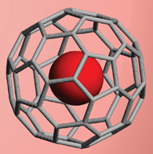**Carbon Polymer Bio-caging**

Bio-cage is a carbon polymer which can be used as a carrier for minerals, including trace minerals and can form nanoparticles after complexation.

**Properties of Neuna® Min**

1. **High Surface Area-to-Volume Ratio**
   * Increases reactivity and adsorption capabilities.
   * Enhances catalytic efficiency in chemical processes.
2. **Enhances Mechanical Strength**
   * Neuna® Min exhibit improved hardness and durability.
   * Used in reinforcement of composite materials.
3. **Improves Thermal Stability**
   * Neuna® Min can withstand high temperatures without significant degradation.
   * Applied in heat-resistant coatings and thermal insulation materials.

**Benefits of Neuna® Min**

* Greater Bioavailability
* Higher Cellular Availability
* Higher Retention
* Lower Faecal Excretion
* Broad Safety Margin

**Applications of Neuna® Min**

* 1. **Environmental Applications**
* **Soil Remediation:** Neuna® Min can break down contaminants in soil, making it safer for agriculture and construction.

**2. Medical and Healthcare**

* **Drug Delivery Systems:** Neuna® Min can be engineered to deliver drugs to specific sites in the body, increasing treatment efficacy and reducing side effects.
* **Antibacterial Coatings:** Silver and copper nanoparticles exhibit strong antimicrobial properties.

**3. Agricultural Applications**

* **Nano-fertilizers:** Improves nutrient absorption and enhance crop yield.